EXERCISE SHEET (WEEK 2)
Name: Mohit Raghavendra
Roll.no: CS25B1022

mkdir CS25B1022
cd CS25B1022
mkdir PSP
mkdir PSP_Practice
2.
cd PSP
// We are in PSP directory
gedit file1.txt
cd ..
// We are back in CS25B1022
cd PSP_Practice
// We are in PSP_Practice directory
gedit file2.txt
3.
// Similarly we use nano like
nano file1.txt
4.
// Output
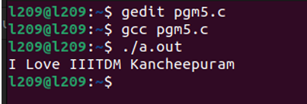
5.
Verified the output

